**A YEARLY ANALYSIS FOR GAMESTOCK PRICE**

**OVERVIEW**

This is an analysis of the yearly price gain that game-stock has made since their launch in the year 2002 and shows the amount of revenue made from their total sales of their stocks such as their (open_price, close_price, high_price, low_price and adjacent close_price ), all these stocks and data are originally procured from (kaggle) a website for downloading useful data, these data for game-stock is added up and compared to each other for the range of five years beginning from the year 2002-01-01 to the year 2022-01-01.

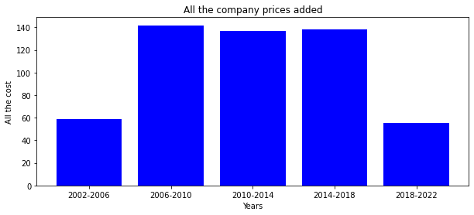

From the bar chart above it can be seen from the yearly price gain of game-stock for the past five years has been going through some shifts, as seen from the year 2002 all the way to 2006 had an average amount of sales but their peak of price sales peaks at 2006 to 2010, then it dropped a bit but not by much between the year 2006 to 2018, but they lost the most price sales by 2018 to 2022.

**Material Used**

Python as Programming Language

PostSQL for Database

Matplotlib for Plotting Charts

Pandas for Dataflow

Jupyter Notebook for Plotting the Chart

**Personal Observation**

From my observation the average price of game-stock witnessed a huge dropped in the average price recently.